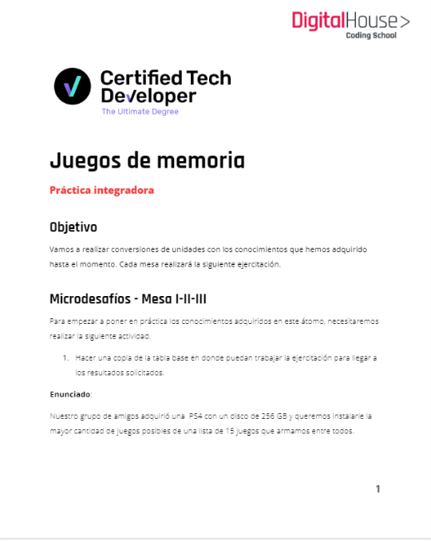

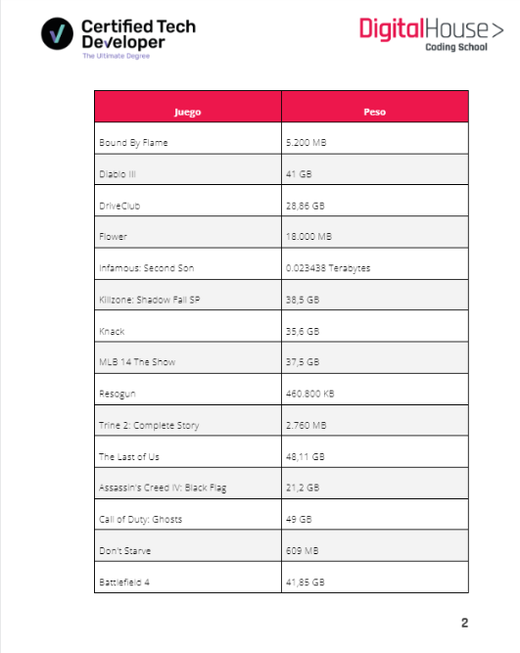

| Bound By Flame | 0.65gb |
| --- | --- |
| Diablo III | 41gb |
| DriveClub | 28.86gb |
| Flower | 2.25gb |
| Infamous: Second Son | 23.438gb |
| Killzone: Shadow Fall SP | 38,5 GB |
| Knack | 35,6 GB |
| MLB 14 The Show | 37,5 GB |
| Resogun | 0.4608gb |
| Trine 2: Complete Story | 2.76GB |
| The Last of Us | 48,11 GB |
| Assassin's Creed IV: Black Flag | 21,2 GB |
| Call of Duty: Ghosts | 49 GB |
| Don't Starve | 0.609gb |
| Battlefield 4 | 41,85 GB |

Sacamos los que estan en rojo

estamos ocupando sin los juegon en rojo 233GB

| total | 371.7878 |
| --- | --- |

| lo que hay que sacar 115,7878gb |
| --- |